Roll No.: _ _ _ _ _ _ _ _ _ _ _ _ _ _ _ _ _ _ _

Amrita Vishwa Vidyapeetham

B.Tech. First Assessment – August 2019

First Semester

Common to all Engineering Departments

19CSE100 Problem Solving and Algorithmic Thinking

**Set-3**

Time: Two hours Maximum: 40 Marks

**Course Outcomes (COs):**

|  |  |
| --- | --- |
| **CO#** | **Course Outcomes** |
| CO1 | Apply algorithmic thinking to understand, define and solve problems |
| CO2 | Understand an algorithm by tracing its computational states, identifying bugs and correcting them |
| CO3 | Apply the basic programming constructs for problem solving |
| CO4 | Design and implement algorithm(s) for a given problem |

**Answer all questions**

**Part A (20 Marks)**

1. The goal of the following flowchart is to add the numbers in boxes 6, 7, 8 and 9 and put the total into box 3. In order to accomplish exactly this – no more and no less, what value should be in box 4 for the flowgorithm to achieve its goal? Explain your answer. [5 Marks][CO2]

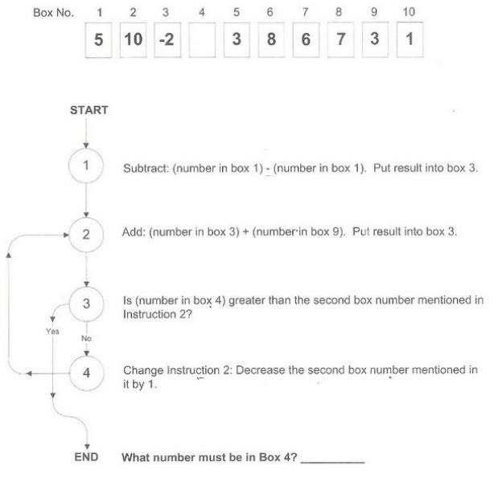

Solution

A) The number in Box 4 must be 7. [2 marks]

B) Since statement 3 compares the number in box 4 and each box number starting from 9 (decremented one at a time) the number in box 4 must be one greater than the box number 6 which must be 7. [3 marks]

1. Given below is an algorithm for *shampooing*. Can you re-write the pseudocode using repetition/loop. Which of the two algorithms (with/without loop) is a better general-purpose algorithm? Explain. [5 Marks][CO3]
   1. Wet hair
   2. Lather hair
   3. Rinse hair
   4. Lather hair
   5. Rinse hair
   6. Stop

Solution

[4 Marks]

* 1. Wet hair
  2. Set value of washCount to 0
  3. Repeat steps i to iii until the value of washCount is 2
     1. Lather hair
     2. Rinse hair
     3. Add 1 to the value of washCount
  4. Stop

The algorithm with repetition is a better general-purpose algorithm because by changing the constant value at step c it allows the hair to be washed more than once. [1 mark]

1. Algorithmic thinking is a five steps process one must go through when presented with a problem from a scientific or any other domain. The five steps given below is jumbled and out of order. Can you give the right order for algorithmic thinking? [5 marks][CO1]
   1. Designing an algorithm
   2. Defining the problem
   3. Formulating the problem mathematically
   4. Implementing the algorithm
   5. Understanding the problem

Solution: [1 mark for each of the right order]

* 1. Defining the problem
  2. Understanding the problem
  3. Formulating the problem mathematically
  4. Designing an algorithm
  5. Implementing the algorithm

1. Given below is an incomplete flowchart that authenticates an ATM card. Also find below the list of statements in jumbled order. Redraw the flowchart with appropriate statements picked from the list so that it does its intended task. [5 Marks][CO2]

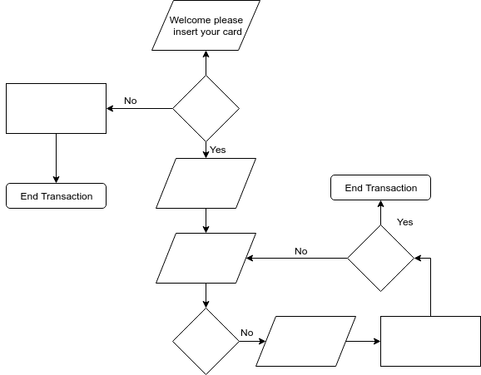

* 1. You have entered an incorrect PIN number
  2. Read card number?
  3. Enter PIN number
  4. Number entered incorrectly > 3 times?
  5. Read PIN number
  6. Error reading card
  7. Increment counter
  8. PIN correct?

Solution:

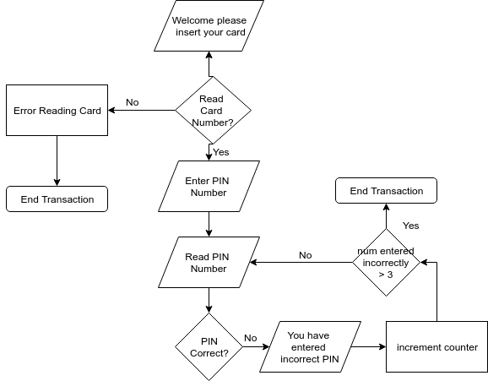

**Part B (20 Marks)**

1. In the Indian Standard Soil Classification System (ISSC) soils are classified into groups according to size and the groups are further divided into *coarse*, *medium* and *fine* sub-groups. The grain-size range is used as the basis for grouping soil particles into *boulder*, *cobble*, *gravel*, *sand*, *silt* or *clay*. The following table provides the classification based on grain-size.

|  |  |  |  |
| --- | --- | --- | --- |
| Very Coarse Soils | Boulder |  | > 300 mm |
| Cobble |  | 80 – 300 mm |
| Coarse Soils | Gravel | Coarse | 20 – 79 mm |
| Fine | 4.75 - 19 mm |
| Sand | Coarse | 2 – 4.74 mm |
| Medium | 0.425 - 1.99 mm |
| Fine | 0.075 - 0.424 mm |
| Fine Soils | Silt |  | 0.002 - 0.074 mm |
| Clay |  | < 0.002 mm |

Write a flowgorithm to classify a set of *grain-size* values into soil groups. [10 Marks][CO3]

A typical program session is as follows.

Welcome to Indian Standard Soil Classification System

size of your grain-size data: 6

Enter the data (mm): 4.8 120 350 0.350 0.001 3

The results of soil classification

4.8mm - Gravel Fine

120mm - Cobble

350mm - Boulder

0.350mm - Sand Fine

0.001mm - Clay

3mm - Sand Coarse

1. At last the first term at the University came to its finish. You have already passed all the exams and wants to know if you get a scholarship. There is the following practice of giving scholarship to students at the University:
   1. if a student has got satisfactory marks, the scholarship is not given,
   2. if a student has passed through the examination with only excellent marks, he gets a personal scholarship,
   3. if a student doesn’t get a personal scholarship and his average mark is not less than 4.5, he gets a high scholarship and
   4. if a student gets neither high nor personal scholarship and doesn’t have satisfactory marks, he gets a common scholarship.

A *satisfactory* mark corresponds to value 3, a *good* mark corresponds to value 4, and an *excellent* mark corresponds to value 5. An average mark for a student is the average value of all the marks this student got in his exams. Write a program to find the type of scholarship given number of subjects and the marks in the subjects (*which should be between 3 and 5*). [10 Marks][CO3]

A sample session follows.

Enter the number of subjects: 3

Enter the marks: 5 5 4

Congratulations! You got a high scholarship.

Do you want to continue (y/n)?: y

Enter the number of subjects: 4

Enter the marks: 3 3 3 3

Oops! You are not eligible for a scholarship.